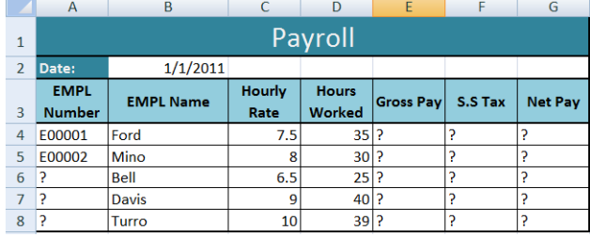

1. Open a new workbook and save the file with the name “Payroll”.

2. Enter the labels and values in the exact cells locations as desired.

3. Use AutoFill to put the Employee Numbers into cells A6:A8.

4. Set the columns width and rows height appropriately.

5. Set labels alignment appropriately.

6. Use warp text and merge cells as desired.

7. Apply borders, gridlines and shading to the table as desired.

8. Format cell B2 to Short Date format.

9. Format cells E4:G8 to include dollar sign with two decimal places.

10. Calculate the Gross Pay for employee; enter a formula in cell E4 to multiply Hourly

Rate by Hours Worked.

11. Calculate the Social Security Tax (S.S Tax), which is 6% of the Gross Pay; enter a

formula in cell F4 to multiply Gross Pay by 6%.

12. Calculate the Net Pay; enter a formula in cell G4 to subtract Social Security Tax from

Gross Pay.

13. Save file as Exercise 1.

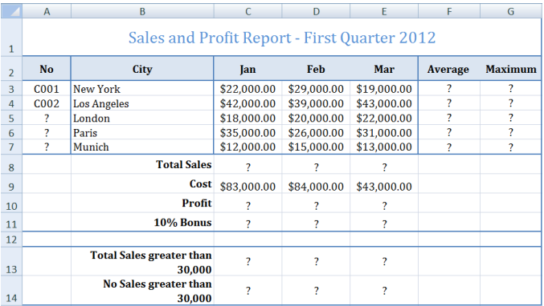

1. Create the worksheet shown above.

2. Set the Text alignment, Columns width and high appropriately.

3. Use AutoFill to put the Series Numbers into cells A5:A7.

4. Format cells C3:G7, C8:E11, C13:E13 to include dollar sign with two decimal places.

5. Find the Average Sales and Maximum Sales for each City.

6. Find the Total Sales for each Month.

7. Calculate the Profit for each month.

8. Calculate the 10% Bonus, which is 10% of the Profit.

9. Find the Total Sales for each Month; only for sales greater than 30,000.

10. Find the No of Sales for each Month; only for sales greater than 30,000.

11. Create the following Charts:

12. Save file as Exercise 2.

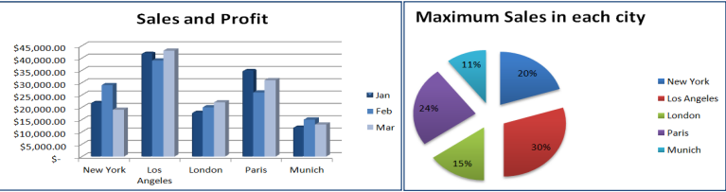

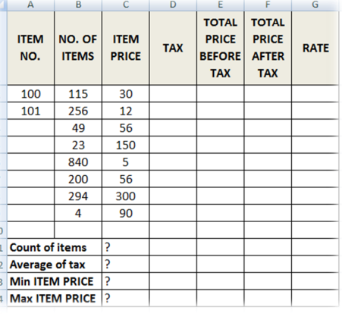

1. TAX (If ITEM PRICE is less than 100, TAX is 50, otherwise it should be 100).

2. TOTAL PRICE BEFORE TAX

3. TOTAL PRICE AFTER TAX

4. RATE (If TOTAL PRICE AFTER TAX > 3500 then the rate is “HIGH”, otherwise it is

REASONABLE).

5. Find Count of Items, Average of Taxes, Min Item PRICE and Max Item PRICE.

6. Save file as Exercise 3.